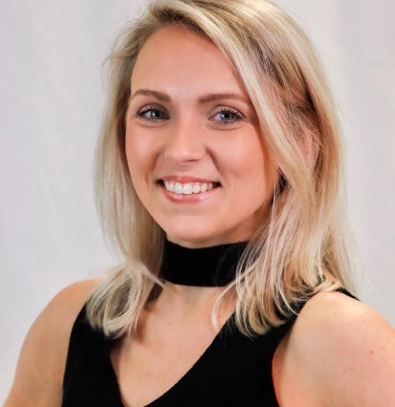
Allison Reeder
Virginia Beach, VA
Phone: (757) 339-3525
Email: allinilsen.danceandart@gmail.com
Height: 5’0”/ Weight: 110Ibs.
IG: allinilsendance WEBSITE: allinilsendance.weebly.com
Live Dance Performance (Selected):
Thanksgiving Day Parade Celeste Kellogg’s ‘The Look’ 2011 Chicago, IL
Benefit Concert Make-A-Wish 2011 Smithfield, VA
Weight (Wait) Of a Moment Bliss Kohlmyer Jacksonville University
Rites of Passage Michael Lomeka Jacksonville University
41st Arts Awards Gala Guest Dancer Jacksonville, FL
CooperMorgan Dance “Honest T” Jacksonville, FL
Mayo Clinic’s Aneurism and Stroke Support Group Solo Performance Jacksonville, FL
Mayo Clinic's Moyamoya Support Group 2024 Jacksonville, FL
Television/Film:
CMT video 2011 Celeste Kellogg’s music video ‘The Look’
National TV Commercial Liberty Tax 2011
National TV Commercial Liberty Tax 2009
National TV Commercial Liberty Tax 2006
National Talk Show Conversations with Denise 2017
Official Music Video ‘On The Low’- Toran Crush 2019
Choreography/Instructing:
Monet School of Ballet Ballet instructor
CooperMorgan Dance Co. Contemp., Jazz, Hip hop instructor for summer intensive
Britney Boyd Dance Co. Contemporary, Jazz, Ballet, Tap instructor
First Coast Center for the Arts Ballet instructor/lyrical, Jazz, Tap Substitute
All Starz Dance Studio Hip Hop, Adult Jazz instructor/Contemp., Tap, Acro Substitute
Fascinatin’ Rhythm School of Dance Ballet, Contemporary, Tap instructor/Musical Theatre, Acro Sub.
The World of Dance & Talent Ballet, Pointe, Contemporary & Tap Instructor
Training and Education:
Jacksonville University BFA in Dance 2017 Jacksonville, FL
Denise Wall’s Dance Energy 2005-2013 Virginia Beach, VA
Ballet/Pointe: Danny Tidwell, Kenney Easter, Tara Foye, Katy Spreadberry, Chebar Williams, Kim Craven, Scott Jovovich, Aimee Long, Victoria Flores Cooke, Joni Petri-Scholtz, Kathy Brenner, Richmond Ballet, Brian Palmer, Cari Coble, Madeline “Jazz” Harvey, Linda Jenkins, Wes Chapman, Tiffany Fish.
Jazz: Denise Wall, Nick Lazzarini, Mark Meismer, Joe Lanteri, Mandy Moore, Doug Caldwell, Taja Riley, Ray Leeper, Sonja Tayeh, Kim McSwain, Stacey Tookey, Joey Dowling, Ade Obayomi, Suzi Taylor, Christopher Smith, Sabra Johnson, Andy Pellick, Michael Lomeka, Alex Blitstein.
Contemporary: Cedar Lake Contemporary Ballet, Travis Wall, Teddy Forance, Mia Michaels, Jason Parsons, Peter Chu, Dee Caspberry, Hani Abaza, Lauren Adams, Jaimie Goodwin, Cara Goodwin, Alex Blitstein, Glenn Edgerton.
Tap: Mike Minery, Chloe Arnold, Danny Wallace, and Anthony Morigerato.
Hip Hop: Misha Gabriel, Ivan Koumeav, Kenny Wormald, Dana Wilson, Jillian Meyers, AC Ciulla, Taja Riley, Tyler Wall.
Modern: Alvin Ailey, Garth Fagan Dance Co., Todd Rosenlieb, Deborah Thorpe, Michael Lomeka, Lana Heylock, Bliss Kholmeyer, Jennifer Muller, James Boyd, Jacksonville Dance Theatre.
Hawaiian: Shirley Copeland, Hawk’s Cay Polynesian dancers.
Flamenco: Victoria Flores Cooke. African: Chloe Arnold, Janelle Spruill. Ballroom: Stanislav Savich.
Competitions/Conventions Attended: ACDA (American College Dance Association), Jump, Nuvo, 24/Seven, The Dance Awards, NYCDA, Hollywood Vibe, Showbiz; (Competed with Denise Wall’s Dance Energy Company).
Competition/Convention Work Experience:
Showbiz & PrimeTime – Backstage Elite Dance Challenge - Judge
​Imagine Dance Challenge - Judge

